Chapter 4: The Organization of Life
Section 1, Day 1
Defining an Ecosystem
- __________________________________ are communities of organisms and their abiotic environment.
- Examples are an ___________________________________________________.
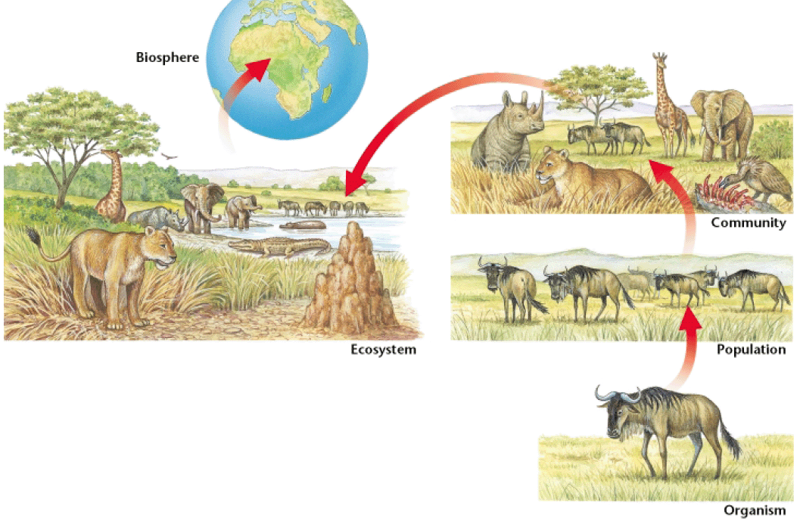

The Components of an Ecosystem
- In order to survive, ecosystems need five basic components:
  - _________________________________
  - _________________________________
  - _________________________________
  - _________________________________
  - _________________________________
- Plants and rocks are components of the land ecosystems, while most of the energy of an ecosystem comes from the ___________________________.
Biotic and Abiotic Factors
- ____________________________________________ are environmental factors that are associated with or results from the ______________________________________________________, which includes plants, animals, dead organisms, and the waste products of organisms.
- _______________________________________________ are environmental factors that are _______________________________________________ with the activities of living organisms which includes air, water, rocks, and temperature.
Organisms
- _____________________________________ are living things that can carry out life processes independently.
- _____________________________________ are groups of organisms that are closely related can mate to produce fertile offspring.
Populations
- _____________________________________ are groups of organisms of the same species that live in a specific geographical area and interbreed.
- An important characteristic of a population is that its members _________________________________________________________________ rather than with members of other populations
Communities
- __________________________________________ are groups of various species that live in the same habitat and interact with each other.
- __________________________________________ is part of a community.
- The most obvious difference between communities is the __________________________________________ they have.
Habitat
- ______________________________________ are places where an organism usually lives.
- Organisms tend to be very _________________________________ to their natural habitats.

Chapter 4: Organization of Life
Section 2, Day 2
Evolution by Natural Selection
- English naturalist _______________________________________ observed that organisms in a population differ slightly from each other in form, function, and behavior.
- Some of these differences are _____________________________________.
- Darwin proposed that the _________________________________________ a strong influence over which individuals survive to produce offspring, and that some individuals, because of certain traits, are more likely to survive and reproduce than other individuals are.
- _____________________________________ is the process by which individuals that have favorable variations and are better adapted to their environment survive and reproduce more successfully than less well adapted individuals do.
- Darwin proposed that over many generations, natural selection causes the characteristics of ____________________________________________.
- _________________________________________ is a change in the characteristics of a population from one generation to the next.
Nature Selects
- Darwin thought that nature selects for certain traits, such as sharper claws, because organisms with these traits are __________________________________________________________________.
- Over time, the population includes a greater and greater proportion of organisms with the ________________________________________.
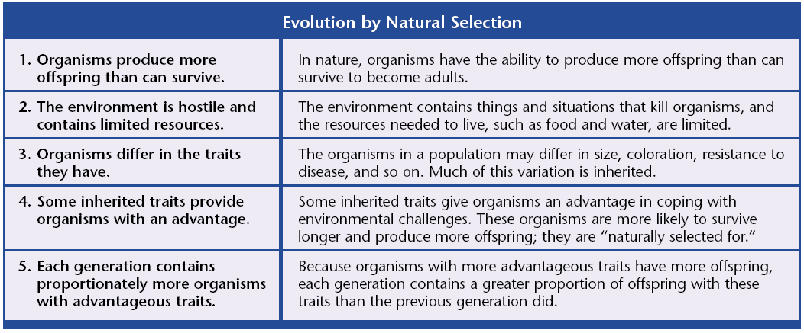
- As the populations of a given species change, so does the species.
Nature Selects
- An example of evolution is a population of deer that became isolated in a cold area.
- Some of the deer had genes for thicker, warmer fur.
- These deer were more likely to survive, and their young with thick fur were more likely to survive to reproduce.
- _______________________ is the process of becoming adapted to an environment.
- It is an _______________________________________________________________________.
Coevolution
- The process of two species evolving in response to long-term interactions with each other is called _________________________________.
- An example is the ___________________________________________, which has a long, curved beak to reach nectar at the base of a flower.
- The honeycreeper’s adaptation is a ______________________________________.
- The plant has two adaptations:
  - The first is the ____________________________, which attracts the birds.
  - The second is the ______________________________ that forces pollen onto the bird’s head when the bird sips nectar.
Evolution by Artificial Selection
- _______________________________________________ is the selective breeding of organisms, by humans, for specific desirable characteristics.
Evolution of Resistance
- _______________________________________ is the ability of an organism to tolerate a chemical or disease-causing agent.
- An organism may be resistant to a chemical _______________________________________________________________________.
- Humans promote the evolution of resistant populations by trying to _______________________________________________________________________.
Pesticide Resistance
- A pesticide sprayed on corn to kill grasshoppers, for example, may kill most of the grasshoppers, but those that survive happen to have a gene that protects them from the pesticide.
- These surviving insects pass on this resistant gene to their offspring.
- Each time the corn is sprayed; more grasshoppers that are resistant enter the population.
- Eventually the entire population will be resistant, making the pesticide useless.

Chapter 4: Organization of Life
Section 3, Day 3
The Diversity of Living Things
- Most scientists classify organisms into __________________ kingdoms based on different characteristics.
- Members of the six kingdoms get their food in different ways and are made up of different types of ____________________, the smallest unit of biological organization.
- The cells of animals, plants, fungi, and protists all contain a ______________________.
- While cells of bacteria, fungi, and plants all have _______________________________.
Kingdom | Characteristics | Examples
Archaebacteria |  | Methanogens (live in swamps and produce methane gas) and extreme thermophiles (live in hot springs)
Eubacteria |  | Proteobacteria (common in soils and in animal intestines) and cyanobacteria (also called blue-green algae)
Fungi |  | Yeasts, mushrooms, molds, mildews, and rusts
Protists |  | Diatoms, dinoflagellates (red tide), amoebas, trypanosomes, paramecia, and Euglena.
Plants |  | Ferns, mosses, trees, herbs, and grasses
Animals |  | Corals, sponges, worms, insects, fish, reptiles, birds, and mammals

Bacteria
- ______________________________________ are extremely small, single-celled organisms that usually have a cell wall and reproduce by cell division.
- Unlike all other organisms, bacteria lack _______________________________.
- There are two main kinds of bacteria, ________________________________________________________________.
Bacteria and the Environment
- Some kinds of bacteria _________________________________________________________________ of other organisms and return the nutrients to the soil.
- Others recycle nutrients, such as _______________________________________________.
- This conversion is important because nitrogen is the main component of ________________________________________________.
- The bacterium, Escherichia coli or ___________________________, is found in the intestines of humans and other animals and helps digest food and release vitamins that humans need.
Fungi
- A _________________________________ is an organism whose cells have nuclei, rigid cell walls, and no chlorophyll and that belongs to the kingdom Fungi.
- ___________________________________ act like mini-skeletons that allow fungi to stand up right.
- A _________________________________ is the reproductive structure of a fungus.
- Fungi get their food by ____________________________________ that help break down organic matter, and then absorbing the nutrients.
- Like bacteria, fungi play an important role in ___________________________________________________________________.
- Some fungi, like some bacteria, cause ____________________________________.
- _______________________________________ is an example of a condition caused by fungi.
Protists
- _________________________are diverse organisms that belong to the kingdom Protista.
- Most protists are ________________________________________________, including diatoms, which float on the ocean surface,
- Another protist, __________________________________, is the one-celled organism that causes the disease malaria.
- From an environmental standpoint, the most important protists are ______________________.
- Algae are plantlike protists that can make their ___________________________________________________________________.
Plants
- Plants are many-celled organisms that make their own food ___________________________________________________________________.
- __________________________________ are connected by vascular tissue, which has thick cell walls and serves is system of tubes that carries water and food.
Lower Plants
- Their descendents alive today are small plants such as __________________________.
- ________________________________________were the first vascular plants, with some of the ferns being as large as small trees.
Gymnosperms
- _______________________________________ are woody vascular see plants whose seeds are not enclosed by an ovary or fruit.
- __________________________________________________ are gymnosperms that bear cones.
- Much or our lumber and paper comes from gymnosperms.
- Gymnosperms have several adaptations that allow them to live in drier conditions than lower plants.
  - They can produce _______________________, which protects and moves sperm between plants.
  - These plants also produce ____________________, which protect developing plants from drying out.
  - A conifer’s _________________________________ also lose little water.
Angiosperms
- ______________________________________are flowering plants that produce seeds within fruit. Most land plants are angiosperms.
- The ___________________________________ is the reproductive structure of the plant.
- Most land animals are dependent on _________________________________________.
Animals
- Animals cannot make their own food. They must take it in from the environment.
- Animal cells also have no cell walls, making their bodies soft and flexible.
Invertebrates
- ______________________________________ are animals that do not have backbones.
- These organisms are only mobile when they are _________________________.
- More ______________________________ exist on Earth than any other type of animal.
- Insects are successful for many reasons:
  - _____________________________________________________
  - _____________________________________________________
  - _____________________________________________________
  - Their __________________________________________ allows them to live on little food and to hide from enemies in small places.
- Bloodsucking insects transmit human diseases such as _______________________________________________________________________.
Vertebrates
- ________________________________________ are animals that have a backbone, and includes mammals, birds, reptiles, amphibians, and fish.
- The first vertebrates were _________________________, but today most vertebrates live on land.
- The first land vertebrates were __________________________.
- These animals were successful because they have an almost ______________________________________________, which allows the egg to hatch on land, away from predators in the water.
Vertebrates
- Birds are _________________________________ vertebrates with feathers.
- Mammals are warm-blooded vertebrates that have __________________________________________________________________.

